Meet The Pride of the Tribe’s New Associate Band Director Cheyne LaBonte

Newly appointed Associate Band Director of Seminole High School (SHS), Cheyne LaBonte, took time recently to answer a few questions. Mr. LaBonte, who grew up in Sanford, attended Florida State University (Go Noles!) and completed his internship at Winter Springs High School.
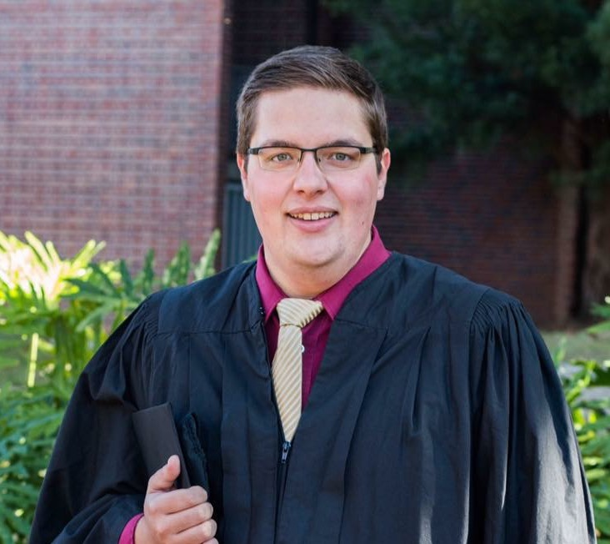
What makes the Pride of the Tribe so successful?
The students going above and beyond makes it so successful.
From being individually prepared to perform to executing leadership
responsibilities, (whether it is their own job or not) helps the Pride of
the Tribe run as efficiently as it does.

What is the biggest challenge with this group?
I’d say the sheer size of the program presents its own set of
challenges. Seminole is lucky to have such a high number of students
involved in the band program. However, Mr. Malcolm, the students,
and the parents, meet this challenge with ease.

What made you want to work at Seminole?
To be fair, I went to high school at Seminole. Ever since I knew I wanted to be a band director, my “dream job” was at Seminole. This was exactly that, a dream, until it became an unbelievable reality.

What is Mr. Malcolm’s best quality?
His compassion and dedication to the students.
What are your goals for the group?
To continue the excellence that Seminole has seen for numerous past years. I hope to meet the expectations of the students and I hope that they meet mine.
What is the best advice you got as a student?
This will seem cliché, but “Dream Big.” And we all know whom that advice came from.
Who was your best teacher and why?
In high school it was definitely Mr. Malcolm, but we’ll give someone else the spotlight here. Dr. Clifford Madsen at FSU was the head of the Music Education and Music Therapy programs (he basically helped invent music therapy). I always left his class intrigued, thinking about the past ninety minute lecture and wanting more. He truly is a master in his field.
What makes a good musician?
Honestly, I think that motivation and dedication go a long way when it comes to being a musician. For example, practicing for 2 hours each day in college when you could be spending time with friends or going to lunch takes a lot of these qualities.

What do you want students in your group to walk away with?
Obviously, as a music teacher, I hope they are better musicians and have the tools to continue their musical growth if they choose to. I also wish to see them leave Seminole good people who can contribute to society in their own way.
What is your favorite part of being a teacher?
Again, risking seeming cliché, I would say my favorite part is seeing the “light bulb moment.” Seeing a student “get” the concept you are teaching them makes this job worth it every time.

